**OUTPUT**

**Google Chrome Browser:**

**User Interface :**

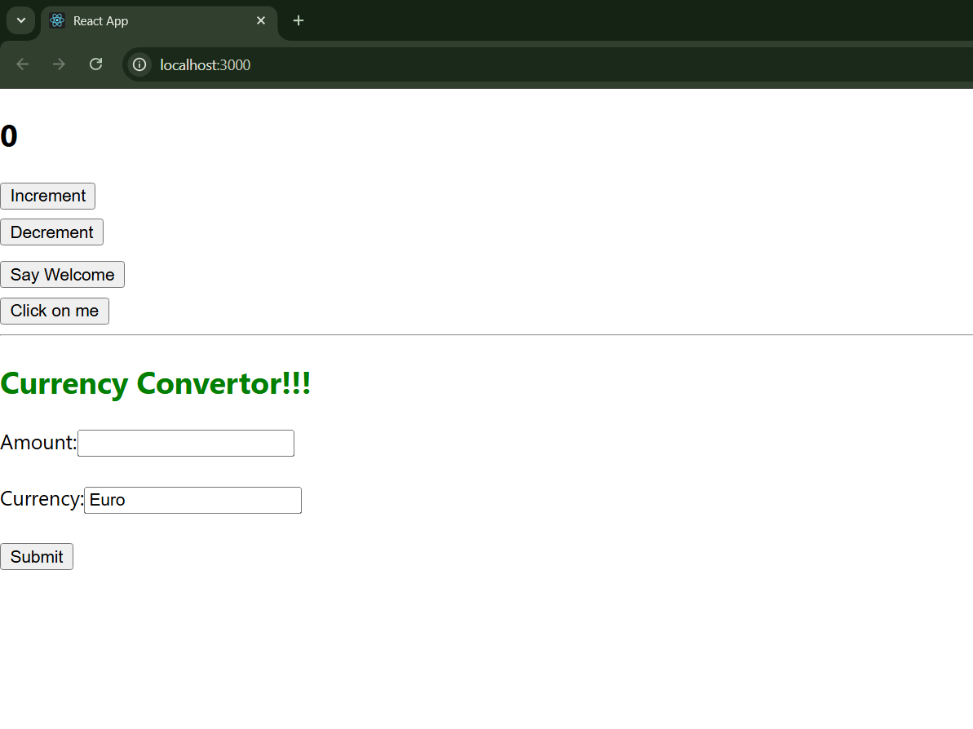

**After Clicking “Increment” :**

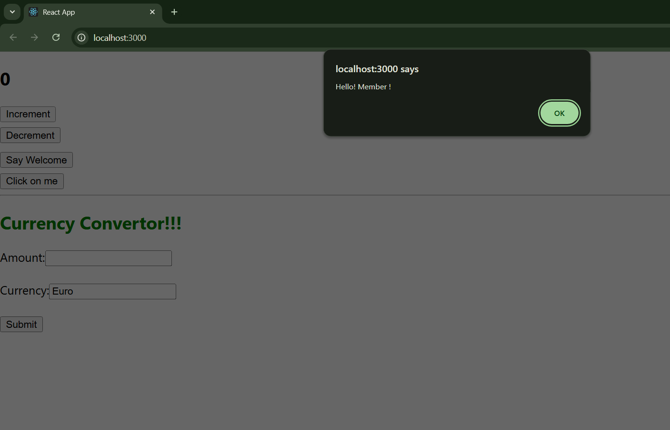

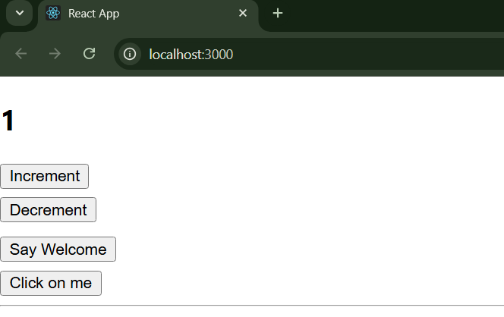

**After Clicking “Decrement” :**

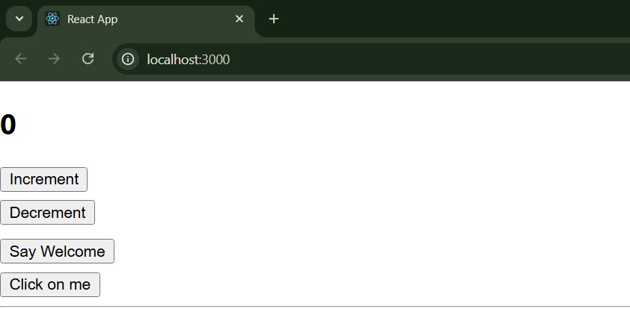

**After Clicking “Say Welcome”:**

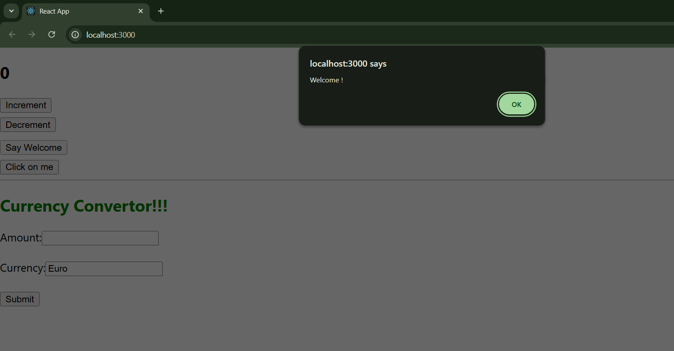

**After clicking “Click on me”:**

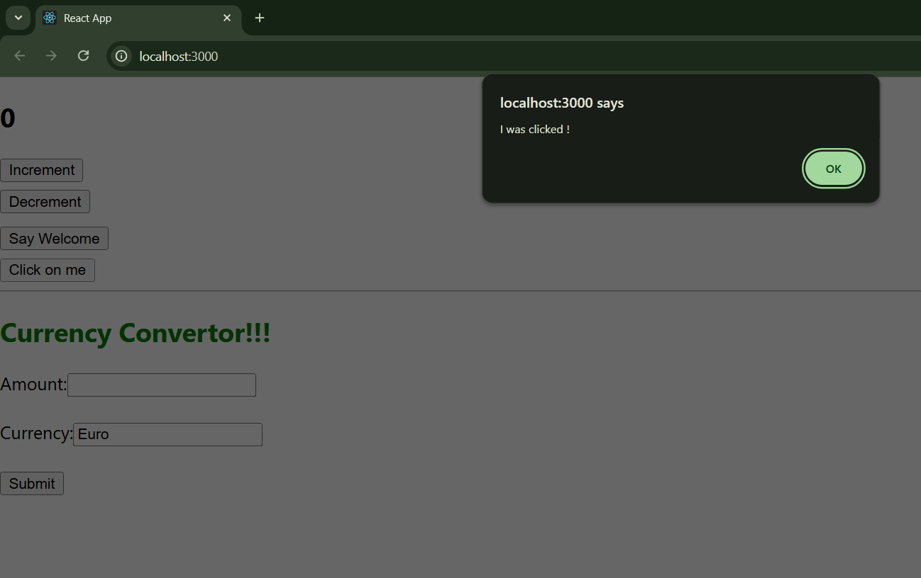

**Currency Conversion OUTPUT:**

**Amount = 80**

**Result = 6400**

